Laszlo Accessibility Test Cases

Required Environment: All test cases must utilize embed.js within the html wrapper for loading the xxx.lzx.swf files.

All test cases must support Java Script.

All test cases must utilize JAWS v7.0 and Flash player v7.x

Keyboard navigation and activation only. NO MOUSE. Tab key to move from element to element and the spacebar to activate the element - buttons, radio knobs,

All test cases must speak the required elements ONE TIME only, unless stated otherwise.

All test cases must properly function on Windows 98 SE, Windows ME, Windows NT 4.0 w/SP3, Windows 2000 Professional, Windows XP Professional

Test Case Number | Objective | Required Elements | Expected Results
Screen layout for test cases 1 and 2

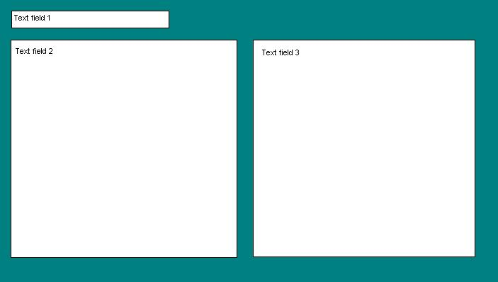
1 | Determine if JAWS is running and speak all screen elements. | Minimum of 3 text fields of which 2 must be multiline and contain no less than 50 words of text each. | - JAWS is not running – alter one of the text fields to report that JAWS is not running.  - JAWS is running – read the text fields from top of screen down and left to right. (1, 2, and 3)
2 | Selectively speak screen elements.  a) Read text fields1 and 3 only. | Minimum of 3 text field of which 2 must be multiline and contain no less than 50 words of text each. | - Text fields 1 and 3 are read in order.  - Text field 2 is never read.
Screen layout for test cases 3 through 5

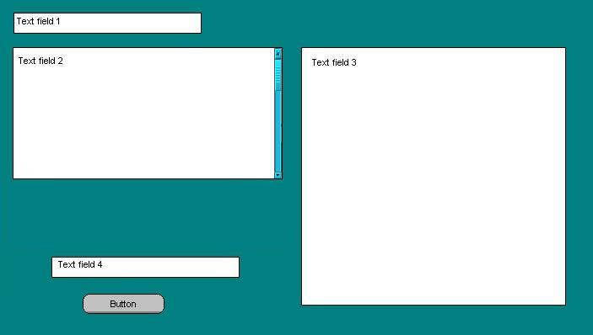
3 | Selectively speak screen elements before and after it is modified.  - Read text fields 1, 2, and 4 and button label.  - Activate button and change the contents of text fields 1, 3, and 4  - Read text fields 1, 2, and 4 and button label after change. | Minimum of 4 text fields of which 2 must be multiline and contain no less than 100 words of text each.  1 button labeled “Change” | - Text fields 1, 2, and 4 are read in order  - Text field 3 is never read.  - Button label text is read last.  - Tab to button and hit the spacebar to activate – change the text contents in fields 1, 3, and 4.  - Text fields 1, 2 and 4 are read again with the new content in fields 1 and 4. (Text field 3 is not to be spoken at any time).  - Read button label text.  NOTE: Text field 2 should contain enough text such that the scroll bar is active. The entire text field must be read visible or not.
4 | Selectively speak screen elements in a different order.  - Read in the following order: text fields 2, 1, 4, button label, text field 3.  - Activate button and change contents of text fields 1, 3, and 4.  - Read in the following order: text fields 2, 1, 4, button label, text field 3 after changes. | Minimum of 4 text fields of which 2 must be multiline and contain no less than 100 words of text each.  1 button labeled “Change” | - Text fields 2, 1, and 4, button label, and text field 3 are read in order.  - Tab to button and hit the spacebar to activate – change the text contents in fields 1, 3, and 4 and the label on the button.  - Text fields 2, 1, and 4, button label, and text field 3 are read in order.
5 | Selectively speak screen elements in a different order.  - Read in the following order: text fields 2, 1, 4, button label, text field 3.  - Activate button and change contents of text fields 1, 3, and 4 and change the order of reading to text fields 4, 3, 2, 1.  - Read the text fields after changes in the new order. | Minimum of 4 text fields of which 2 must be multiline and contain no less than 100 words of text each.  1 button labeled “Change” | - Text fields 2, 1, and 4, button label, and text field 3 are read in order.  - Tab to button and hit the spacebar to activate – change the text contents in fields 1, 3, and 4 and the label on the button and change the order of the text fields to 4, 3, 2, 1.  - Text fields 4, 3, 2, 1 are read in the new order.
6 | Selectively speak screen elements or alternate field description before and after it is modified.  - Read text fields 1, 2, and 4 and button “aaDescription” alternate text.  - Activate button and change the contents of text fields 1, 3, and 4 and the “aaDescription” alternate text for the button. | Minimum of 4 text fields of which 2 must be multiline and contain no less than 100 words of text each.  1 button labeled “Change” with the “aaDescription” | - Text fields 1, 2, and 4 are read in order  - Text field 3 is never read.  - Button label text is read last.  - Tab to button and hit the spacebar to activate – change the text contents in fields 1, 3, and 4 and the “aaDescription” value for the button  - Text fields 1, 2 and 4 are read again with the new content in fields 1 and 4. (Text field 3 is not to be spoken at any time)  - Read the new “aaDescription” for the button.
Screen layout for test cases 7 and 8 (2 Screens)

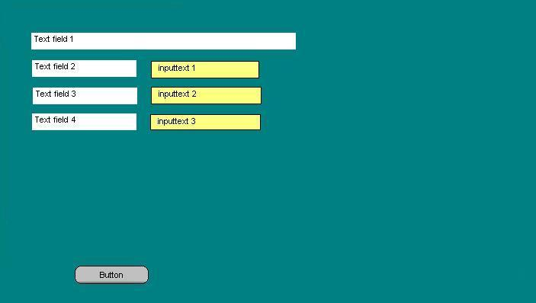
Screen 1
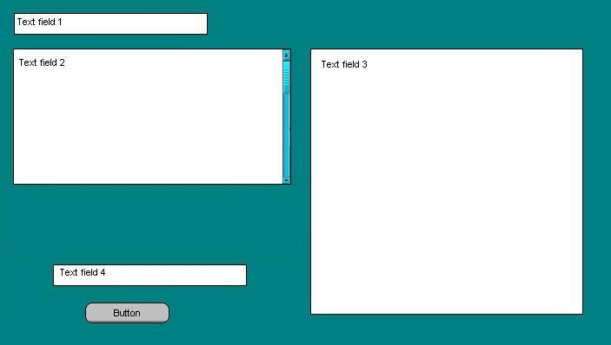
Screen 2

A single xxx.lzx.swf file should contain both these screens. When started screen 1 is visible and screen 2 is invisible. Each screen must be contained within its own lzx file and included into the main lzx file. Screen 1 contains text fields 1 through 4 of which 2, 3, and 4 are actually labels for the three inputtext fields. When screen 1 is loaded the inputtext fields must be blank. Focus should be in inputtext 1 when screen 1 first displays. None of the text fields may ever receive focus, only inputtext and the button.

7 | Speak all elements of screen in order from top to bottom, left to right.  - Enter a word in inputtext field 1 and speak that word while typing.  - Depress the Tab key.  - Enter a word in inputtext field 2 and speak that word while typing.  - Depress the Tab key.  - Enter a word in inputtext field 3 and speak that word while typing.  - Depress the Tab key. (Focus should now be on the button).  - Depress the spacebar.  - Make screen 1 invisible and make screen 2 visible.  - The content of inputtext 1 should be passed into screen 2 and entered into text field 1 using a JAVA script function utilizing the lzSetCanvasAttribute.  - The content of inputtext 3 should be passed into screen 2 and entered into text field 4 using a JAVA script function utilizing the lzSetCanvasAttribute.  - Speak all elements of screen 2 in order, top to bottom, left to right.  - Activate button and change the contents of text field 3, and the “aaDescription” alternate text for the button.  - Read all text fields and button “aaDescription” after the change. | Screen 1 – 4 text fields, 3 inputtext fields and 1 button labeled “OK”.  Screen 2 - Minimum of 4 text fields of which 2 must be multiline and contain no less than 100 words of text each.  1 button labeled “Change”.  A Single HTML file will be used for this test | - Text field 1 is read.  - Text field 2 is read followed by inputtext 1  - Text field 3 is read followed by inputtext 2  - Text field 4 is read followed by inputtext 3  - Button label is read.  - Text is read while it is entered in inputtext 1  - Text is read while it is entered in inputtext 2  - Text is read while it is entered in inputtext 3  - The button is activated.  - Screen 1 becomes invisible and screen 2 becomes visible.  - Screen 2 is read from top to bottom, left to right.  - Tab to button and hit the spacebar to activate – change the text contents in field 3, and the “aaDescription” value for the button  - Text fields 1, 2 and 4 are read again with the new content in fields 1 and 4. (Text field 3 is not to be spoken at any time)  - Read the new “aaDescription” for the button.
Two xxx.lzx.swf files will be used for this test, one for each screen. Two HTML files will be used for this test: each will invoke one screens lzx.swf file. When HTML file 1 is started, screen 1 appears. When screen 1 is loaded the inputtext fields must be blank. Focus should be in inputtext 1 when screen 1 first displays. None of the text fields may ever receive focus, only inputtext and the button. After the button is activated, the entries contained within inputtext fields 1, 2, and 3 must be output and the second HTML file will enter the data into screen 2.
8 | Speak all elements of screen in order from top to bottom, left to right.  - Enter a word in inputtext field 1 and speak that word while typing.  - Depress the Tab key.  - Enter a word in inputtext field 2 and speak that word while typing.  - Depress the Tab key.  - Enter a word in inputtext field 3 and speak that word while typing.  - Depress the Tab key. (Focus should now be on the button).  - Depress the spacebar.  - Make screen 1 invisible. Pass the entered data from inputtext fields 1, 2 and 3 to the HTML.  - Issue a redirect to invoke HTML file 2 from within HTML file 1.  - The content of inputtext 1 should be passed into screen 2 and entered into text field 1 using a JAVA script function utilizing the lzSetCanvasAttribute.  - The content of inputtext 3 should be passed into screen 2 and entered into text field 4 using a JAVA script function utilizing the lzSetCanvasAttribute.  - Speak all elements of screen 2 in order, top to bottom, left to right.  - Activate button and change the contents of text field 3, and the “aaDescription” alternate text for the button and the order to 4, 3, 2, 1.  - Read all text fields and button “aaDescription” after the change. | Screen 1 – 4 text fields, 3 inputtext fields and 1 button labeled “OK”.  Screen 2 - Minimum of 4 text fields of which 2 must be multiline and contain no less than 100 words of text each.  1 button labeled “Change”.  2 HTML files will be used for this test | - Text field 1 is read.  - Text field 2 is read followed by inputtext 1  - Text field 3 is read followed by inputtext 2  - Text field 4 is read followed by inputtext 3  - Button label is read.  - Text is read while it is entered in inputtext 1  - Text is read while it is entered in inputtext 2  - Text is read while it is entered in inputtext 3  - The button is activated.  - Screen 1 becomes invisible and screen 2 becomes visible.  - Screen 2 is read from top to bottom, left to right.  - Button is activated.  - Text fields read in the order 4, 3, 2, 1.  - “aaDescription” for the button is read.
Screen layout for test cases 9 plus (3 Screens)

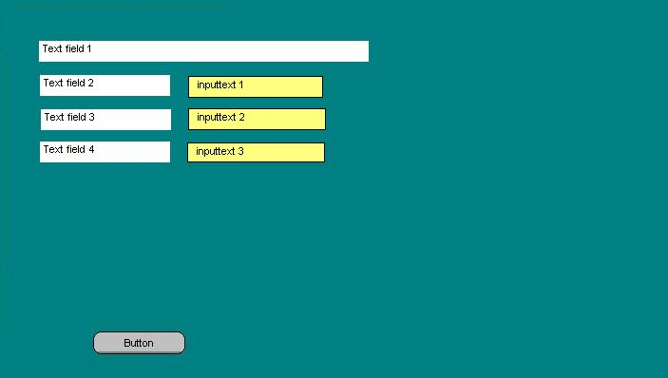
Screen 1
Screen 2

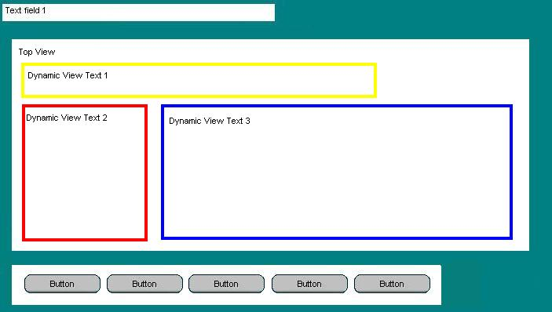
Screen 3

Two xxx.lzx.swf files will be used for this test, one for screen1 and one that will contain screens 2 and 3. Two HTML files will be used for this test: the first will invoke screen 1’s lzx.swf file. When HTML file 1 is started, screen 1 appears. When screen 1 is loaded the inputtext fields must be blank. Focus should be in inputtext 1 when screen 1 first displays. None of the text fields may ever receive focus, only inputtext and the button. After the button is activated, the entries contained within inputtext fields 1, 2, and 3 must be output and the second HTML file will enter the data into screen 2. After reading screen 2, activate the button to go to screen 3, making screen 2 invisible. Screen 3 contains text field 1 (at the top), a large container view (called Top View), from 1 to 4 dynamically created (and positioned) view, and 5 buttons. Dynamic views mean that the size, shape, position, order, and contents are created at the instant the screen or button is activated. The Dynamic Views and their contents are not predetermined but are generated from the XML file containing this information. For the next series of tests, there can be from 1 to 4 dynamically created views, each of which can contain text, images, radio knobs, additional views nested as far as 10 deep, etc.

9 | Speak all elements of screen in order from top to bottom, left to right.  - Enter a word in inputtext field 1 and speak that word while typing.  - Depress the Tab key.  - Enter a word in inputtext field 2 and speak that word while typing.  - Depress the Tab key.  - Enter a word in inputtext field 3 and speak that word while typing.  - Depress the Tab key. (Focus should now be on the button).  - Depress the spacebar.  - Make screen 1 invisible. Pass the entered data from inputtext fields 1, 2 and 3 to the HTML.  - Issue a redirect to invoke HTML file 2 from within HTML file 1.  - The content of inputtext 1 should be passed into screen 2 and entered into text field 1 using a JAVA script function utilizing the lzSetCanvasAttribute.  - The content of inputtext 3 should be passed into screen 2 and entered into text field 4 using a JAVA script function utilizing the lzSetCanvasAttribute.  - Speak all elements of screen 2 in order, top to bottom, left to right.  - Activate button to make screen 2 invisible and screen 3 visible.  - Read all text within the Top View container including all nested views and their contents from top to bottom, left to right. (Do not read Text Field 1, or any button text.) | Screen 1 – 4 text fields, 3 inputtext fields and 1 button labeled “OK”.  Screen 2 - Minimum of 4 text fields of which 2 must be multiline and contain no less than 100 words of text each.  1 button labeled “Change”.  Screen 3 – 1 text field at the top which will contain the text value from text field 4 of screen 2, a view containing 5 buttons (labeled 1, 2, 3, 4, 5) located at the bottom, and a large top level view in the center. Within the top level view additional views (complete with sufficient text) will be dynamically created and positioned by activating one of the buttons.  2 HTML files will be used for this test | - Text field 1 is read.  - Text field 2 is read followed by inputtext 1  - Text field 3 is read followed by inputtext 2  - Text field 4 is read followed by inputtext 3  - Button label is read.  - Text is read while it is entered in inputtext 1  - Text is read while it is entered in inputtext 2  - Text is read while it is entered in inputtext 3  - The button is activated.  - Screen 1 becomes invisible and screen 2 becomes visible.  - Screen 2 is read from top to bottom, left to right.  - Button is activated.  - Screen 2 becomes invisible and screen 3 becomes visible.  - Contents of dynamic views 1, 2, and 3 are read in order.
10 | Continued from the end of test case 9.  - Activate button 1 (first button on the left).  Screen 3 will be dynamically changed to appear as below:  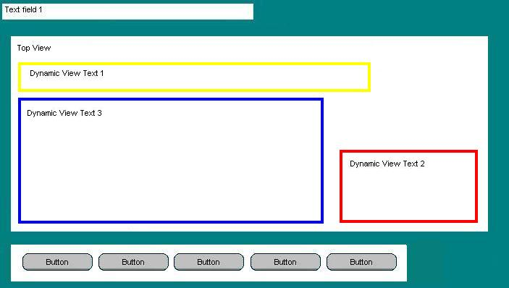  Notice that positions and shape of the 3 dynamic views has changed.  - Read all text within the Top View container including all nested views and their contents from top to bottom, left to right. (Do not read Text Field 1, or any button text.) | Screen 1 – 4 text fields, 3 inputtext fields and 1 button labeled “OK”.  Screen 2 - Minimum of 4 text fields of which 2 must be multiline and contain no less than 100 words of text each.  1 button labeled “Change”.  Screen 3 – 1 text field at the top which will contain the text value from text field 4 of screen 2, a view containing 5 buttons (labeled 1, 2, 3, 4, 5) located at the bottom, and a large top level view in the center. Within the top level view additional views (complete with sufficient text) will be dynamically created and positioned by activating one of the buttons.  2 HTML files will be used for this test | - Contents of dynamic views 1, 2, and 3 are read in order.
11 | Button 2 test here- ordering
12 | Button 3 test here- ordering and alternate text
13 | Button 4 test here- nesting
14 | Button 5 test here- deep nesting
15 | Transition back to button 4
16 | Transition back to button 2 from 4  (jumping around)
17

